* **Use of SELECT command**

create database sales ;

use sales ;

select * FROM sales ;

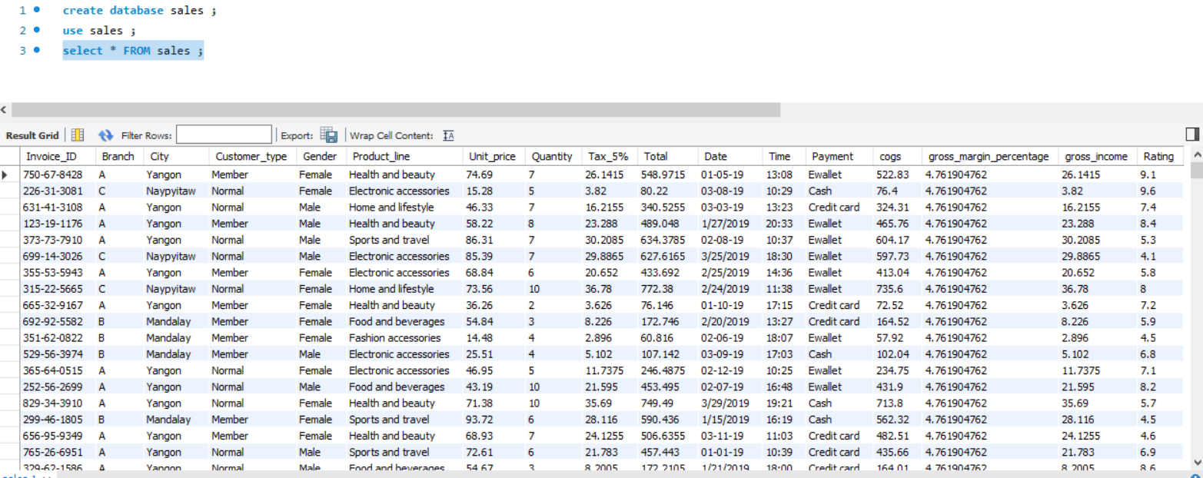

* **Use of aggregate function SUM() : Calculated the total revenue generated from the sales data in the table.**

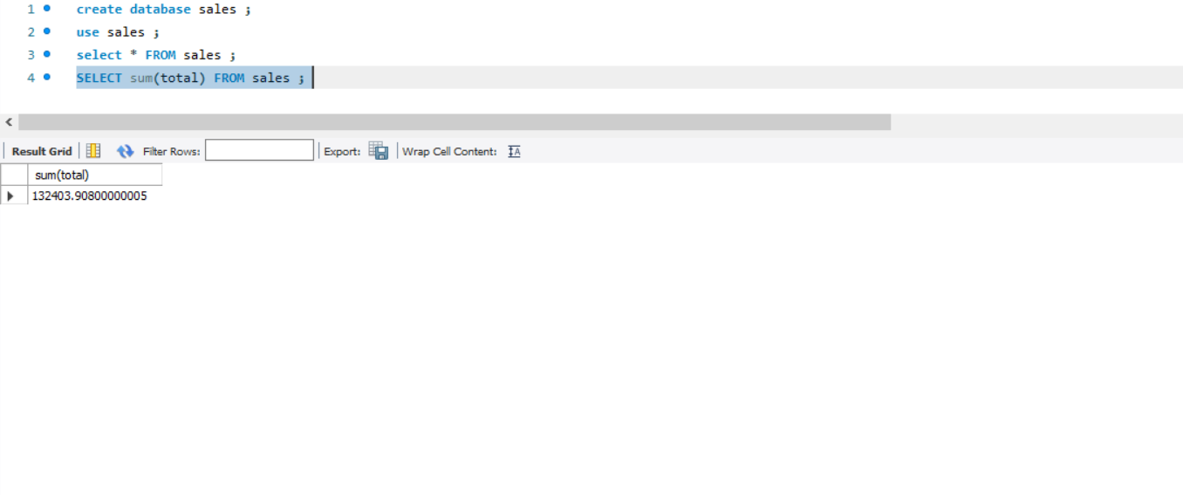

* **Use of GROUPBY: Identified the branch (city) with the highest total sales revenue.**

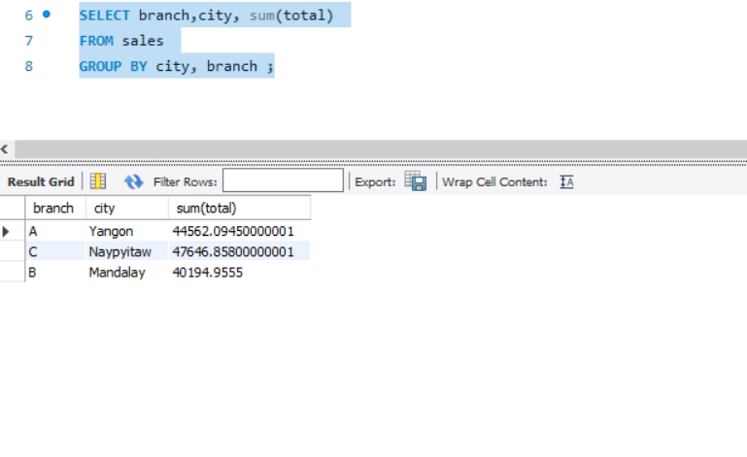

* **Use of ORDERBY: Identified the branch (city) with the highest total sales revenue in descending order.**

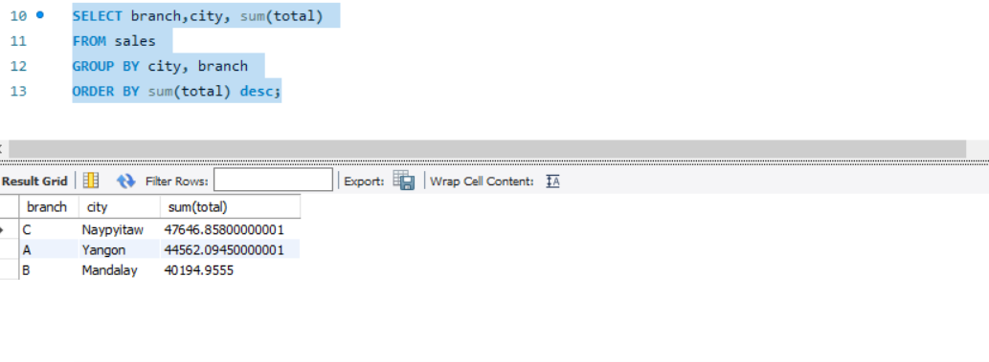

* **Use of Where: Determine the number of quantity of product sold in each product category.**

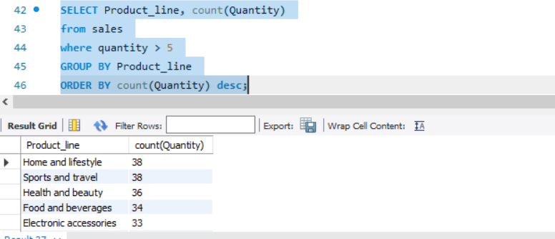

* **Use of aggregate function COUNT() : Calculated the total revenue generated from the sales data in the table.**

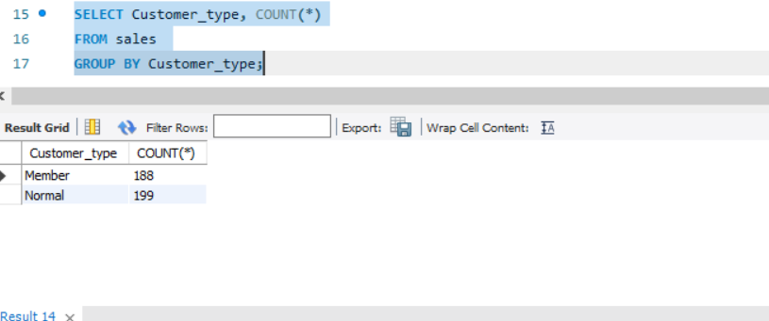

* **Identified the product line that generated the highest gross income and its total.**

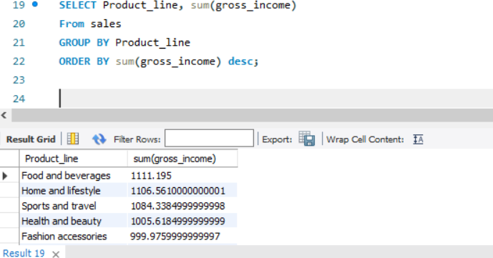

* **Identified the most popular payment method among customers.**

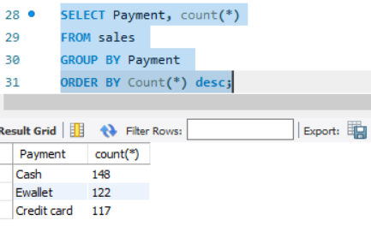

* **Use of aggregate function AVG() : Calculated the average gross margin percentage for each product line.**

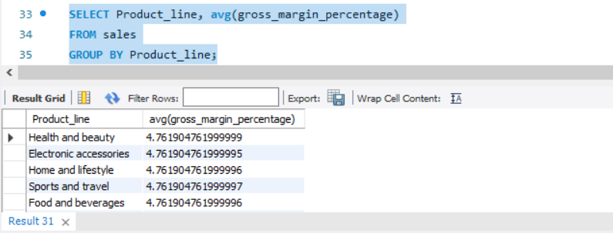

* **Use of subqueries : Determined the day of the week with the highest sales volume.**

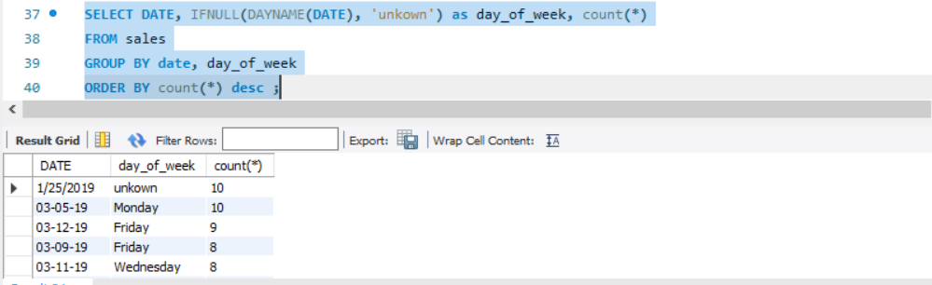

* **Use of subqueries : determine the city and branch in descending where the gross income is greater than the average gross income .**

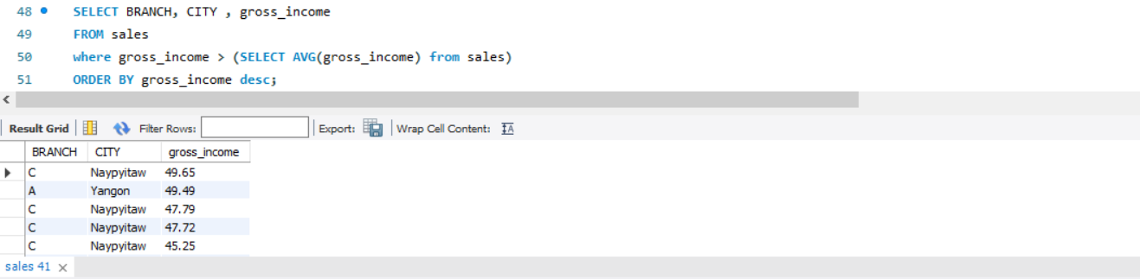

* **Use of view**

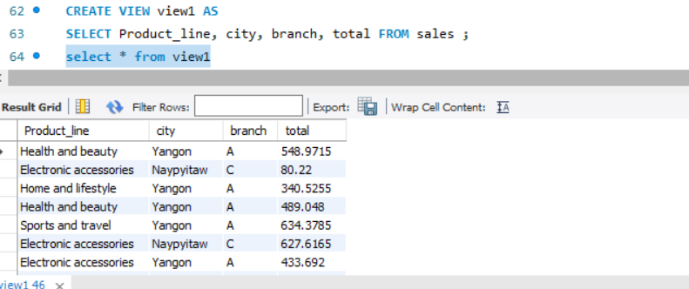

* **Inner joins : keyword selects records that have matching values in both tables. It returns only the rows where there is a match between the columns in both tables.**

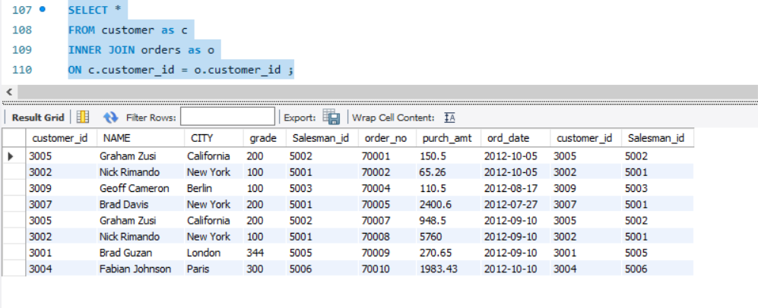

* **Left joins:** The LEFT JOIN (or LEFT OUTER JOIN) returns all records from the left table and the matched records from the right table. If there is no match, the result is NULL on the side of the right table.

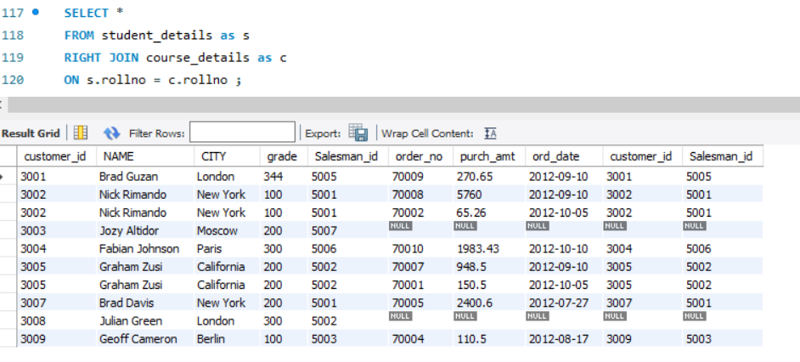

* **Right joins:** The RIGHT JOIN (or RIGHT OUTER JOIN) returns all records from the right table and the matched records from the left table. If there is no match, the result is NULL on the side of the left table.

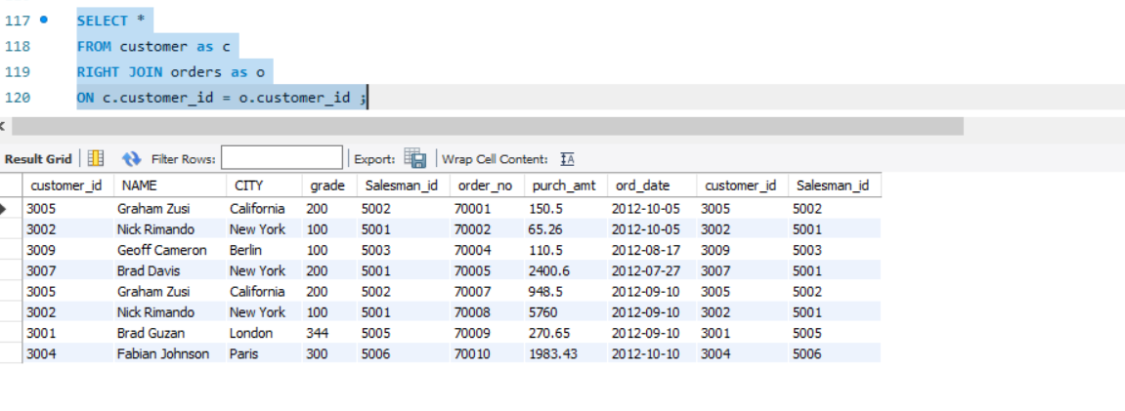

**Optimizing queries with indexes**

